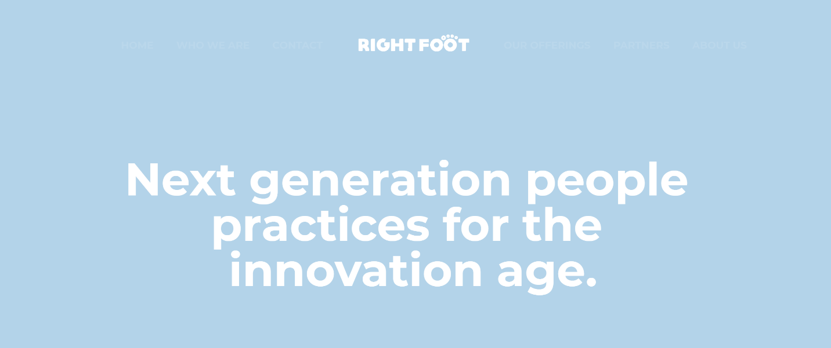

Our mission is helping businesses maintain, scale, and transform in a predictable manor, while focusing on their core asset –

The People.

Key to the success of a business is its ability to harness the power of its key asset. The agility required for the new world of work critically needs the right mix of People Practices and Organizational Agility.

2017 Egypt Regional Presence|
UAE and Saudi Arabia

Providing people and organizational management consultancy aligned to the business objectives of the organization and where it wants to go.

Flagship projects

- Supported the Egyptian Government to deliver on the set up and launch of its Digital Transformation Unit, as part of vision 2030.

- Lead projects with scaling up businesses transitioning from small to mid-size and mid to large. Enabled their strategy of growth and fundraising trajectories.

- Enabled businesses embarking on an automation transition to build their technology roadmap, identify the best fit solution and worked with them on a smooth roll-out. At times, handling it on their behalf as they prepare for the change and other times, developing and aiding with the roll-out of the change.

What makes us different?

Subject Matter Experts
Customer Experience
The Future of Work

01
Our team is composed of talented, accredited experts, who have built knowledge over years as practitioners.
A pool of regional and global consultants.
02
Be it the manager who is responsible for the success of a team, the employee who drives the success of the business, or the HR professional accountable for driving the employee experience internally and for building the organization’s brand externally, our ability to analyze the need, recommend the solution and as need be, be part of its roll out, is addressed with a focus on these different audiences.
03
Our philosophy embraces the fact that the world of work needs to be driven by agility, decision making that is based on data insights and methodologies that are continuously evolving.

Areas of Experience

Combining our ability to understand the root causes of an organization’s needs guided by its business objectives is our start point. A carefully curated analysis is run, a big picture is designed and in partnership with our customers, a roadmap is developed.

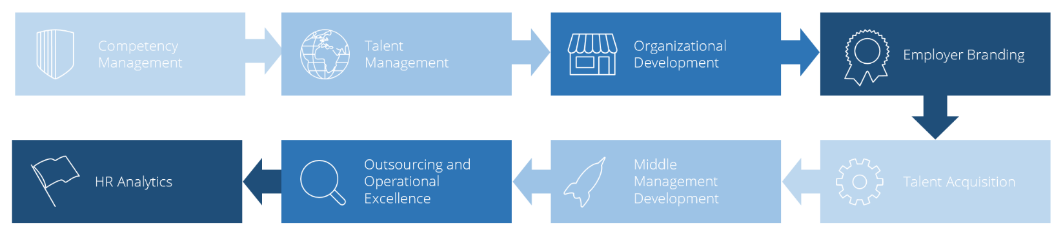

Technology adoption and the path of digital transformation is a journey driven by a purpose. Working with our customers to understand how a tool like technology can help them evolve, operate more efficiently, drive operational excellence, and avail data that can help in making more informed decisions. Our philosophy is that technology is an enabler!

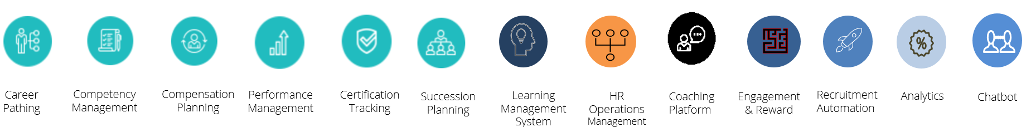

‘More and More organizations are realizing that HR is not the only function to benefit from People Analytics. Over 70% of Executives are making strides to integrate data into everyday decision making.’
Bersin Research Survey - 2017

Our Value Proposition

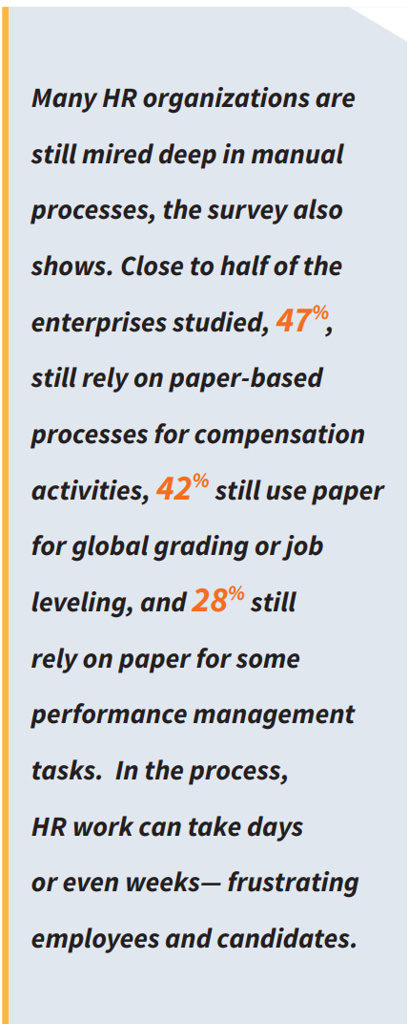
In RightFoot, we recognize how technology and innovation are the building blocks of success and appreciated the fact that legacy technologies were built by technologists, did not embrace the importance of the user experience to its fullest potential. This has impact on adoption levels and results in very high customization costs. As a result, most of the adopters of technology have been mainly large size organizations.

Through our research, we learned that technology companies that have been able to tackle the full 360-spectrum of the employee work experience do not exist.

Some have opted to specialize in the candidate management recruitment dimension, others have focused on objectives and goal setting, others have dug deep in digital learning. After a lot of research, we were able to curate a full spectrum of offerings that tackle the full employee lifecycle.

From an innovation standpoint, we launched a People Analytics Product – Opus – in the later part of 2022. Business decision makers can now better understand the skills of their workforce, translate and optimize their spending patterns and better plan for the growth trajectory of their businesses.

They trusted us.
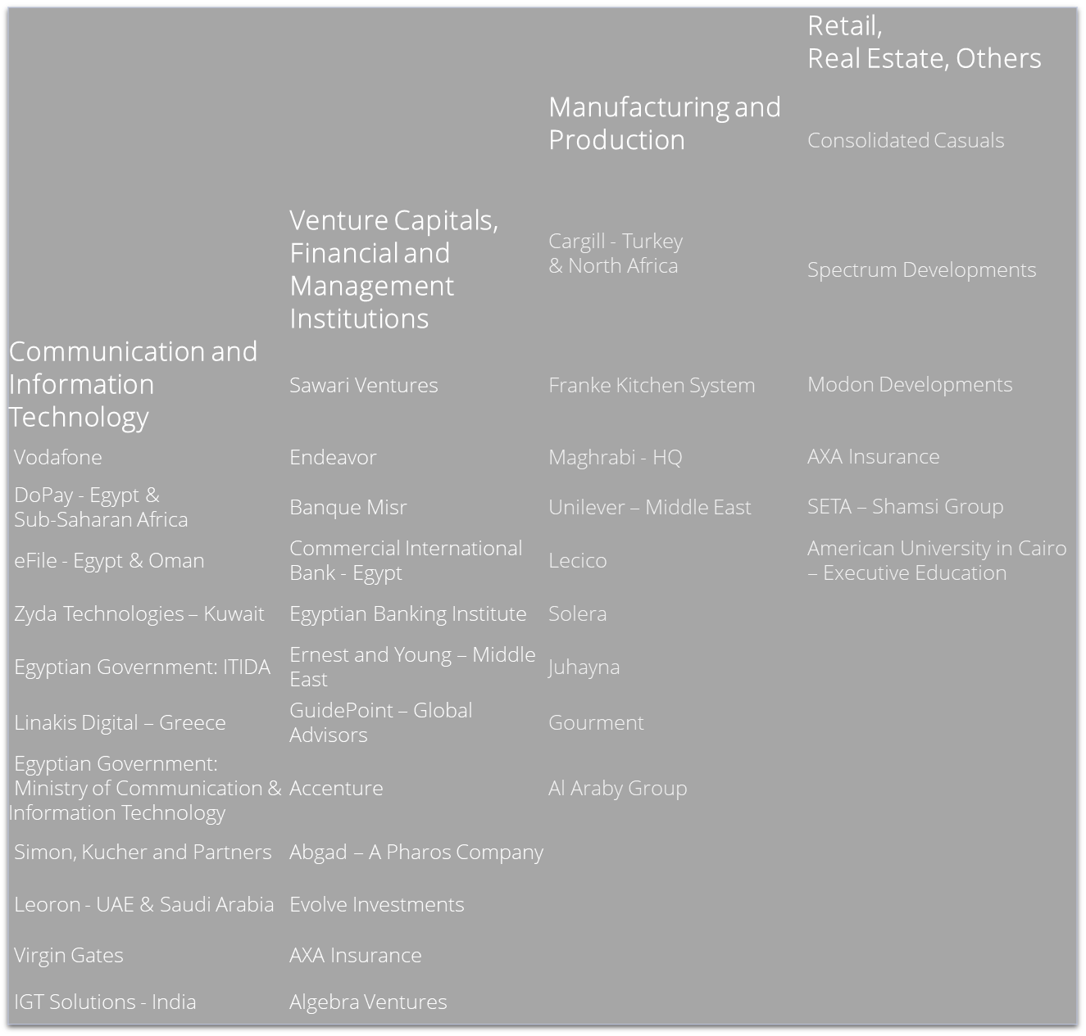
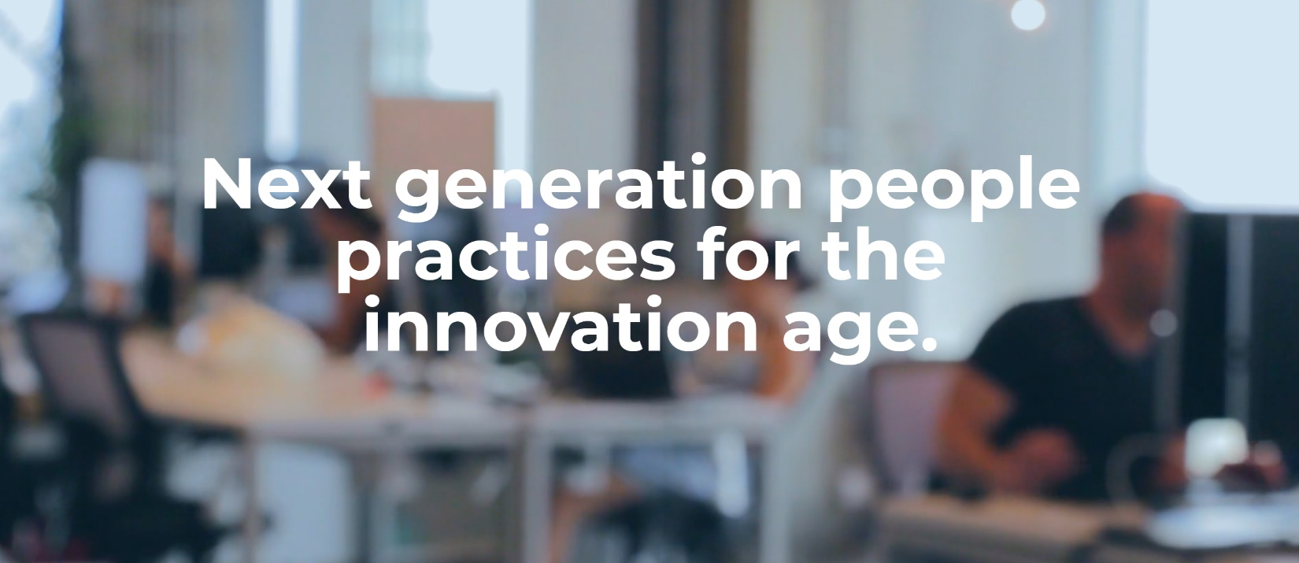

RightFoot.org

Available on the Microsoft Azure Marketplace and AppSource, a SaaS HR Operations solution, MOHR and Opus People Analytics.

Azure Marketplace – MOHR
AppSource – HireHunt and MOHR
Opus Analytics – Coming soon: October 2022

The company name RightFoot represents the fact that at any stage, as a business makes a move, starts, evolves, transitions, irrespective of its size, evaluating the steps always starts by considering starting off on the right foot.

Copyright© 2022 RightFoot

.

